PERSONAL PROFILE  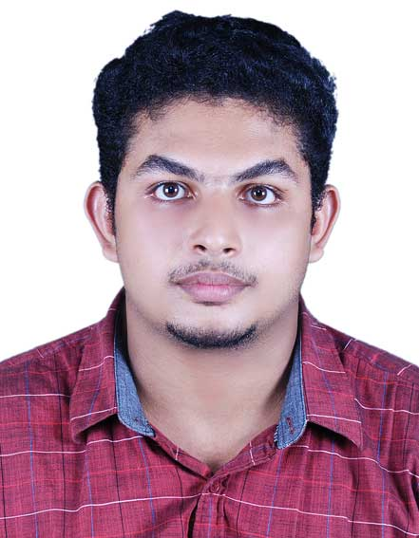  E mail ID:  Sarathprasanth20@gmail.com  Mob:+918606685388  :+919995685388  PRESENT ADDRESS:  Sarath Prasanth  Thundazhikathu veedu  Edavattom  Chirakkara P.O  Kollam Dist  Kerala State  PIN.691578  PERSONAL DATA:  Date of Birth :29/11/1991  Sex : Male  Nationality : Indian  Marital Status: Single  Languages Known: English, Hindi , Tamil , Malayalam  PERSONAL TRAIT:  Creative and logical  Problem solving ability  Co-operative  Good team leadership | SARATH PRASANTH  Career Objective  “To pursue a challenging design career in a dynamic organization that provides skill enhancement and synergizes human potential for growth”  Professional Experience  - Worked as a DESIGN ENGINEER in DOMECH FABRICATORS PVT LTD in RIL-HAZIRA( 5*500TPH CFBC boiler) from 08-08-2014 to 24-10-2016.  Academic Project Work  MINI PROJECT  Topic :- “Design and Fabrication of Pneumatic Lifting Table”  Pneumatic system is used in most important process of industries and harbor. Any work done by pneumatic system, Ex: Lifting, Pulling, Pushing, Pressing, etc., above process can be made to easily vide by pneumatic system. In this method of machineries work is designed through Air Pressure.  MAIN PROJECT  Topic :- “Design and Modification of Chlorine Process Pressure Vessel Nozzle”  At present system Air Paddle system is used for extracting chlorine from chlorine pressure vessel to chlorine storage vessel. This system consists of compressor and air drying unit.  In this project we are designing a nozzle pump system. A nozzle which is connected to the pressure vessel and by using pump connected to the nozzle we can easily transfer data chlorine from chlorine pressure vessel to chlorine storage vessel.  Skills  Auto cad 2D & 3D and SOLID WORKS.  Knowledge of computer assisted design (CAD) software.  Knowledge of engineering, construction, design and materials.  Environmental design skills.  Professional Qualification  ➢ Pursing MBA from INDHIRA GANDHI OPEN UNIVERSITY.  ➢ Graduate in Mechanical Engineering from A R College of Engineering and Technology(67.50%) in 2010-2014.
Educational Qualification

- All India Senior School Certificate Examination (12th ) in science with an aggregate of 65.40% in 2010

- All India Secondary school examination (10th ) with an aggregate of 72.60% in 2008.

Industrial Visits

  - Kerala Electricals and Allied Engineering Company Limited, Kundara
  - K.S.R.T.C Regional Workshop, Mavelikkara
  - KMML, chavara

Declaration

I hereby declare that all the information mentioned above is true to the best of my knowledge and belief.

Place : KOLLAM
Date : SARATH PRASANTH

